Step 1:

## Strategies for gathering requirements:

*Problem Analysis*. Problem Analysis would be very helpful for this small news business. This strategy is a good one to use to solve current problems. Being a new site, it is important to figure out what sort of issues that users face, what kind of things they find issues with, and overall what on the site they find does not work. Ease of use is a big issue for websites and having users report problems is important.

*Root Cause Analysis.* Because *shortstop.news* is a new business, when users report issues with the site the initial problem could be a smaller issue or a symptom of a larger issue which could lead to the root cause of the problems. This analysis could be more challenging as well because finding the root problem is rarely easy.

*Activity-Based Costing.* This strategy would be used to examine the costs of the business and assign costs to them. In a startup, it is important to track where, when, and how the invested money is being used. Assigning costs to every part of the business, from materials to labor, can help to keep track of the total cost for the business.

*Informal Benchmarking*. *shortstop.news* is a new business based around news and using the benchmarking strategy could help to better understand what other news sites and outlets are doing right that could for this site as well. Informal benchmarking will help to find what could be added to the site that the people currently working on it could have not thought of before that could add more value to its users.

*Outcome Analysis*. Using the outcome analysis strategy, a systems analyst would encourage those working on the site to think in the perspective of the customer to better understand the value that the product. Understanding the perspective of the customer or user, can help the project manager to help enable the customers to do as much as they can do with the available product.

*Technology Analysis*. This strategy will ensure that the technology will stay relevant which would be important as this business is largely web-based. Allowing room for the website to be adaptable to changing technology can help it continue to be useful and meet the new goals for the organization.

*Activity Elimination*. As with all businesses over time, there may be certain activities that are still being performed but no longer required. Using the activity elimination strategy, the business would test how the system would work when removing each activity in the process and assessing how the system would still perform.

## Techniques for Requirements-Gathering:

Interview. The most common way to understand what the customers want is to ask them questions regarding the system. This technique works well because it is more of a one on one approach to finding out what the users really think about the system and any problems that they may run into.

*Questionnaire*. This technique could be used if there are already a few things that the developer team may think could be important or useful. This technique is similar to interviewing the customers only it has predetermined questions.

Observation. By using observation, information can be gathered by watching the processes being performed. This could also be useful to follow the way that some customers use the product in every way, seeing their issues happening first-hand.

Step 2:

Determining requirements for the system:

Non-functional requirements

## 1. Operational Requirements

1.1. The system will operate in Windows and Apple environment.

1.2. The system should automatically back up at the end of each day.

1.3 The back-end system should auto-update every time a new is published.

1.4 Update and implement the latest technologies in web development

1.5 Eliminate activities that are no longer required.

## 2. Performance Requirements

2.1. The system will load a page in 2 seconds or less.

2.2. The system will generally follow the 3-click rule.

## 3. Security Requirements

3.1. Secured payment option for premium users.

3.2. Only the system admin can decide which news feed to keep or remove.

## 4. Cultural and Political Requirements

4.1. Maintain cultural and political sensitivity as it covers international news.

## 5. Usability

5.1 User-friendly, even for users with very little computer knowledge.

5.2 Using outcome analysis should produce better news feed to users.

## 6. Availability

6.1 The system should be up and running 24/7.

## 7.Capacity

7.1 The server should be able to handle multiple user requests at the same time.

## Functional Requirements:

1. Manage User reports

1.1 Identify the root cause for the problem and fix it.

1. Manage Premium Users

2.1 Maintain a record of all premium users and update it on a timely basis.

1. Audit Tracking

3.1 Track all the costs from material to labor.

1. Authorization levels

4.1 Set authorization for project manager, public relations, tech head, tech analyst, users and premium users.

1. Legal or Regulatory Requirements

5.1 Comply with the latest legal requirements including copyrights.

.

Step 3:

#### Use Cases:

1. **Automatic Backups**: The system will have automatic backups

2. **Secure Payments**: Any payments will be made securely

3. **Multi-User Support**: There will be multi user support

4. **Run 24/7**: The system will be up and running 24/7

5. **Friendly Website:** Friendly to all users and skill levels

#### Diagrams:

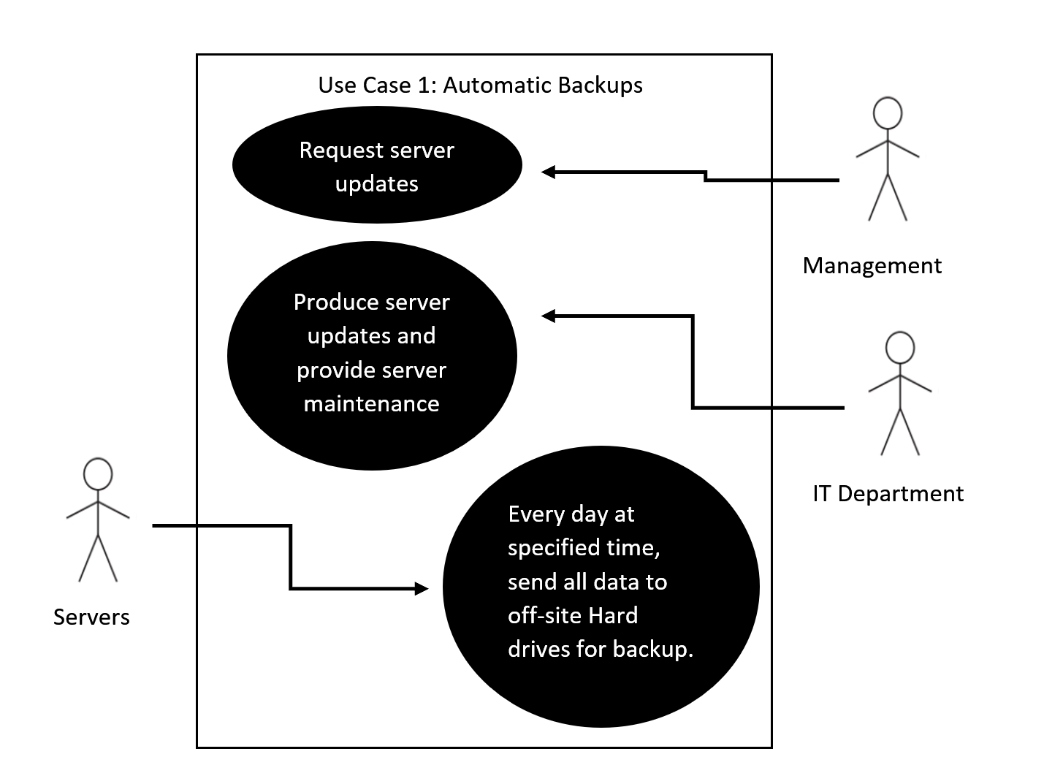

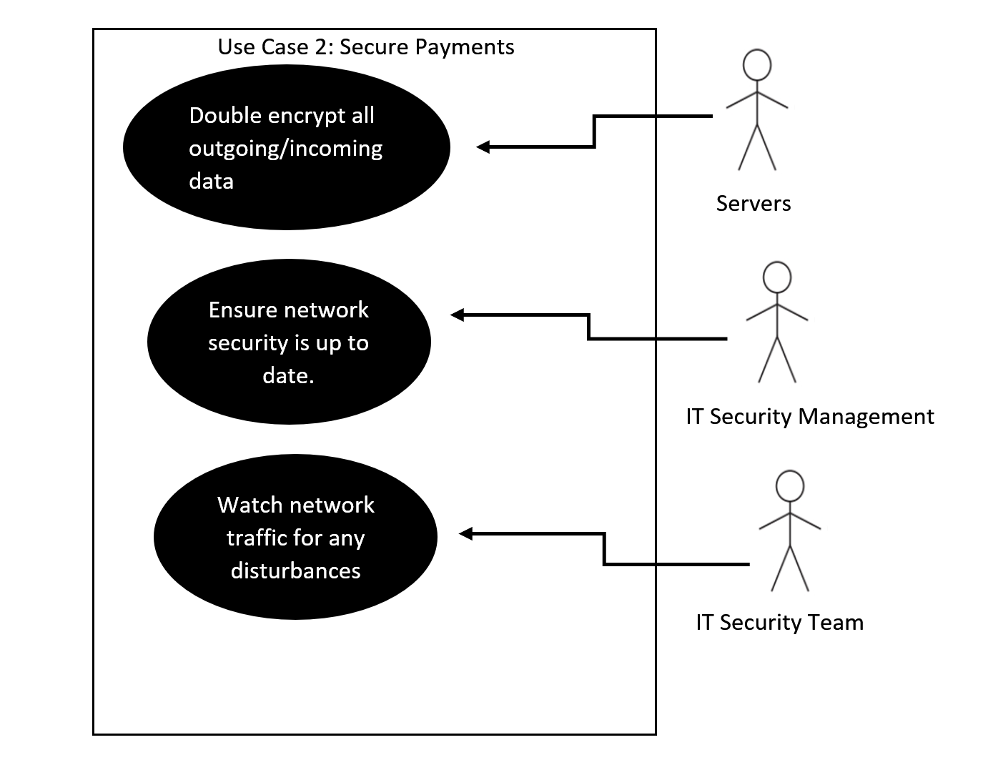

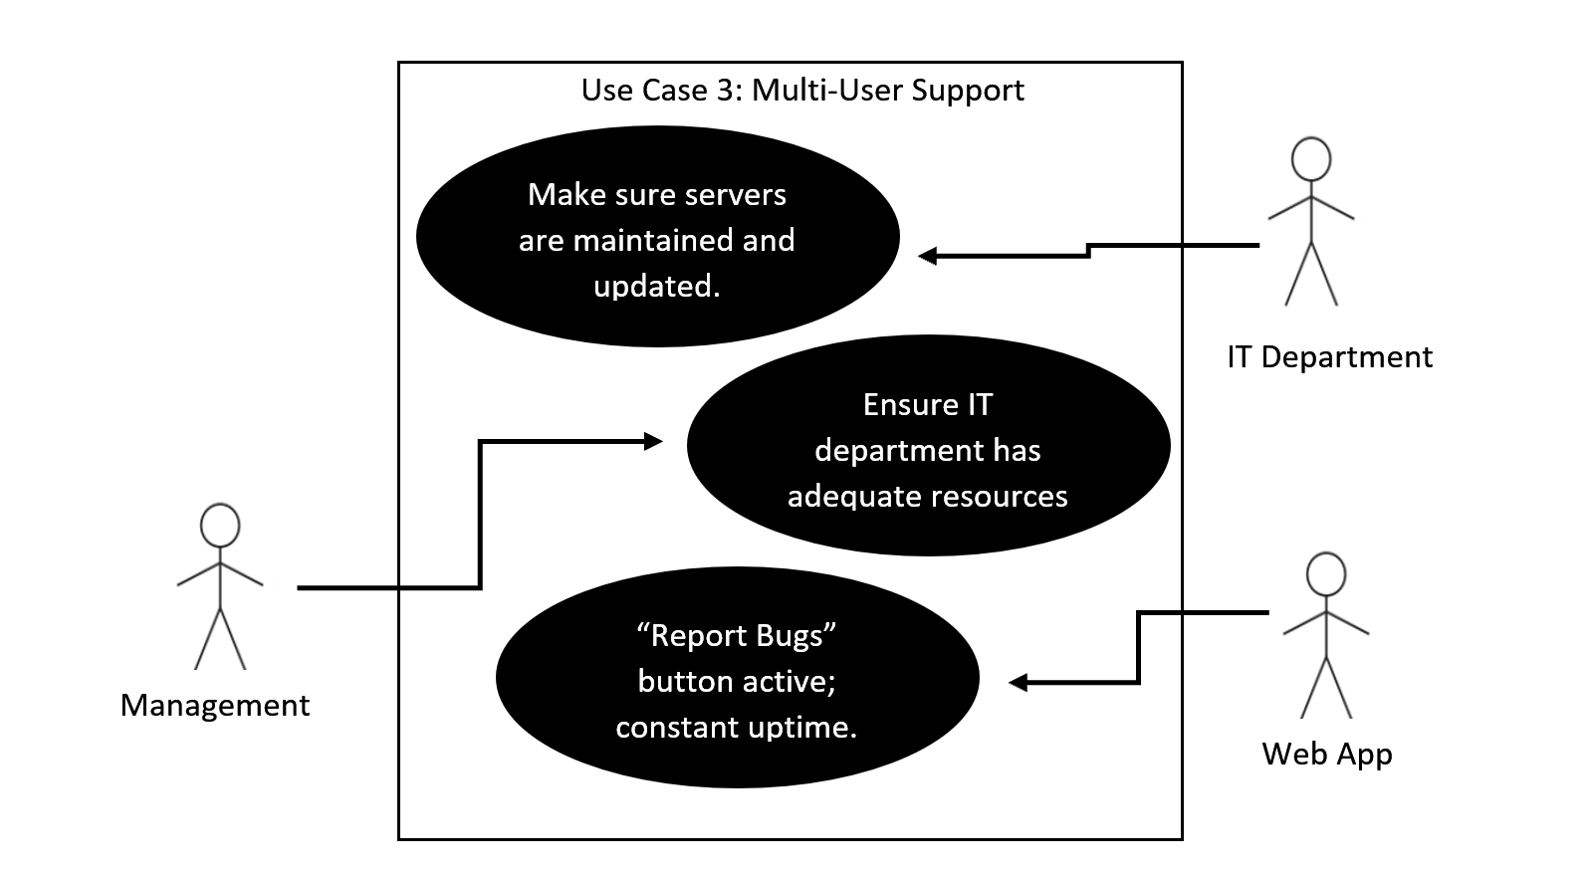

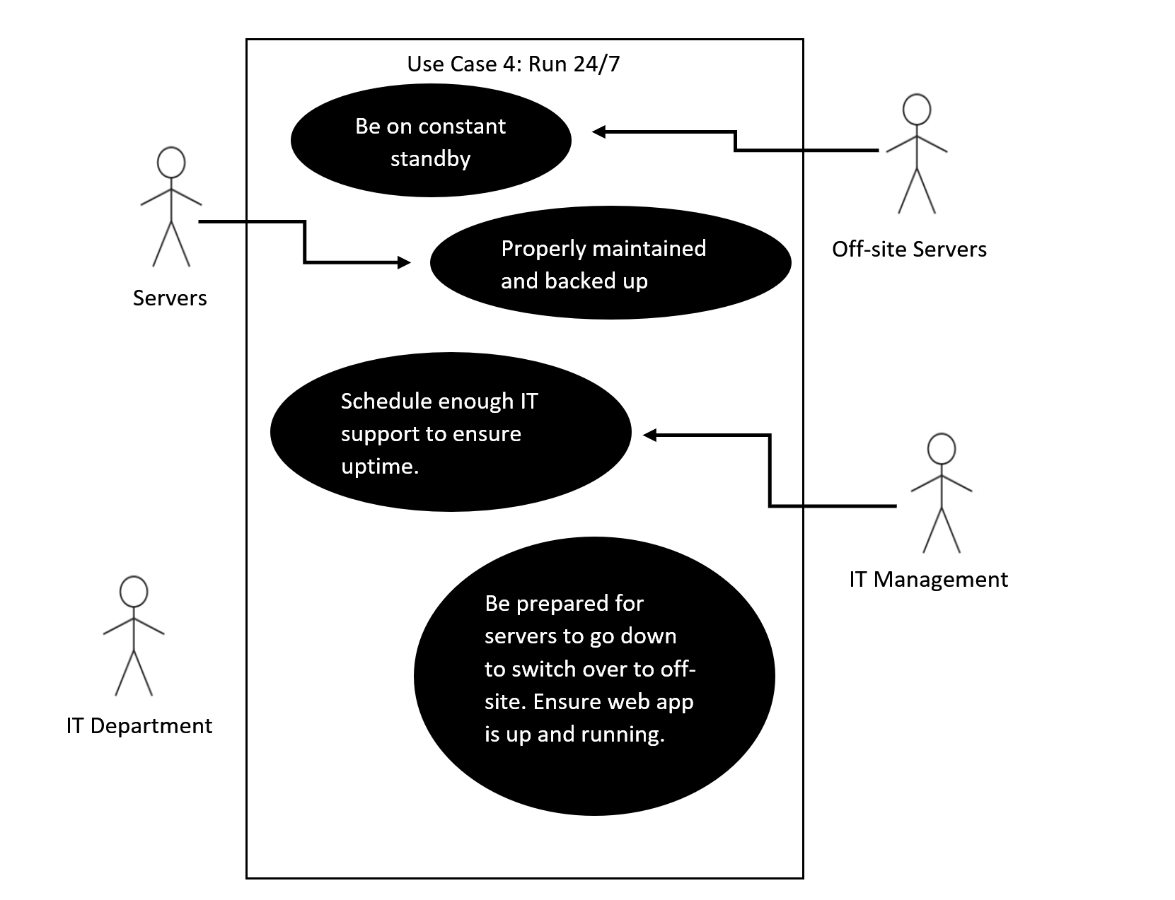

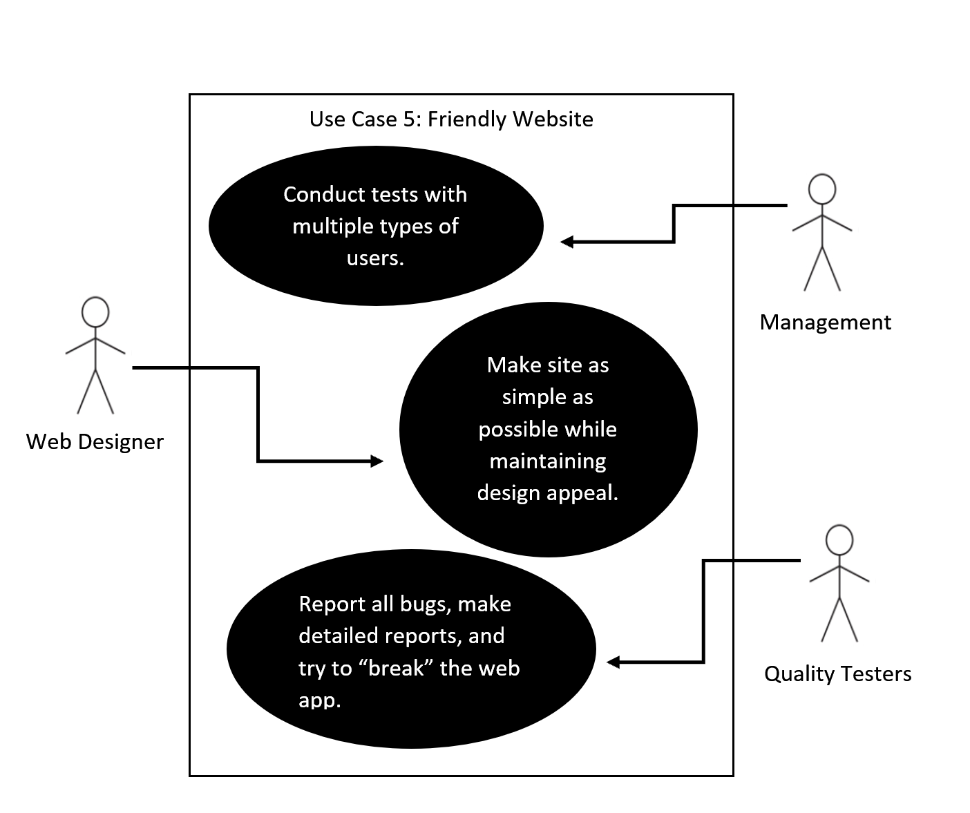

#### Descriptions:

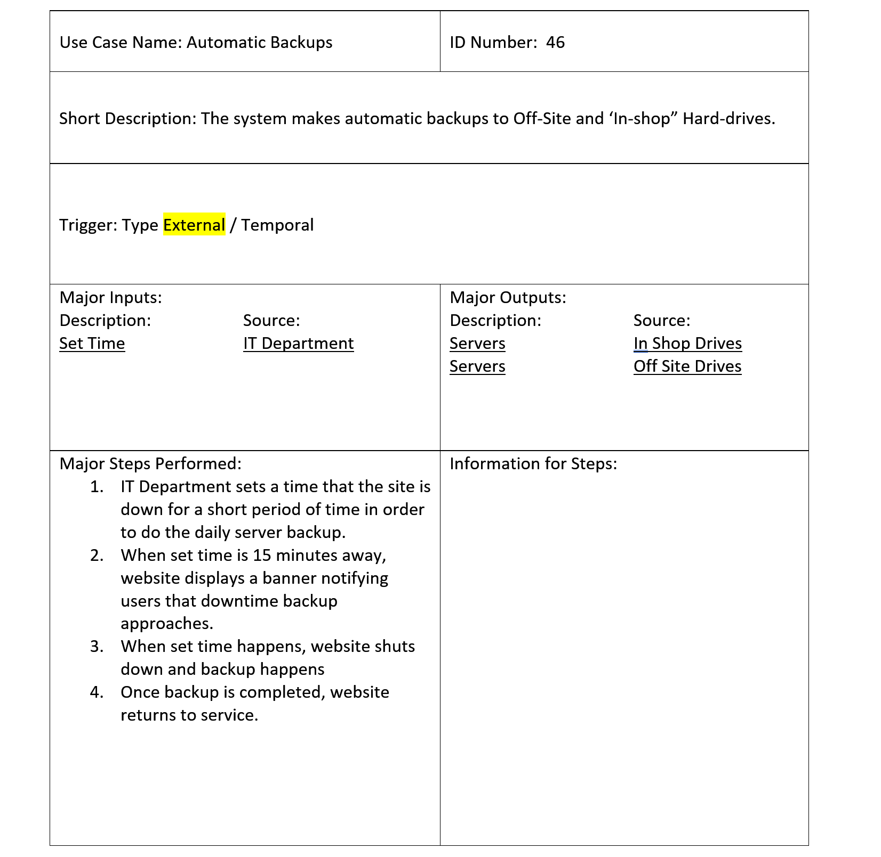

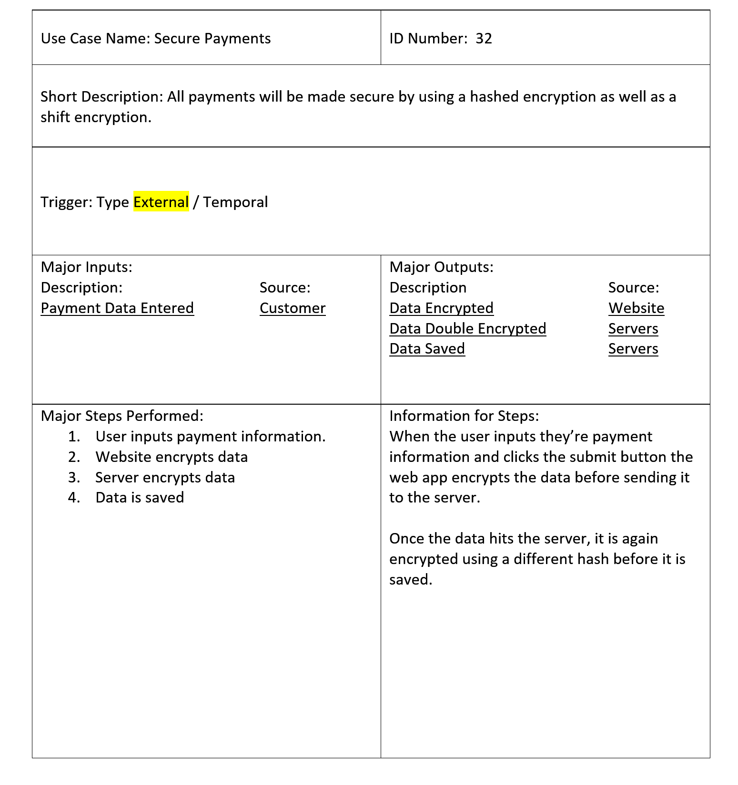

Step 4:

#### Activity Diagrams:

Use Case 1: Automatic Backups:

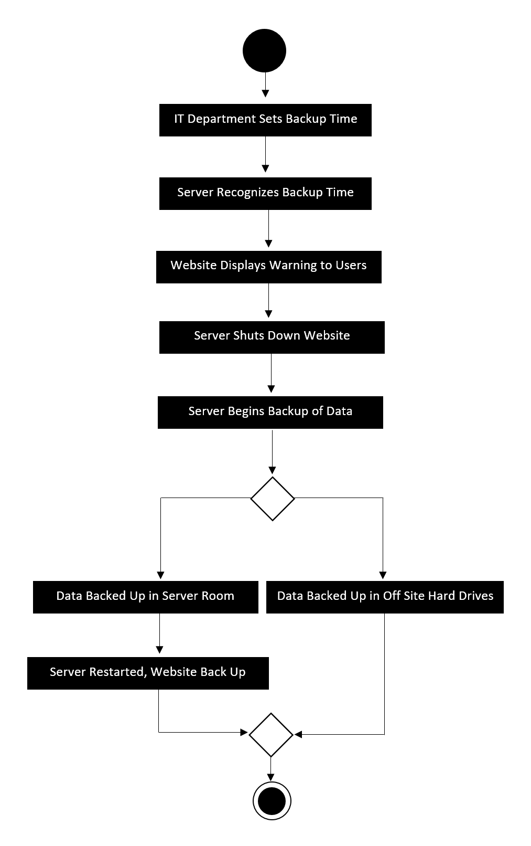

Use Case 2: Secure Payments:

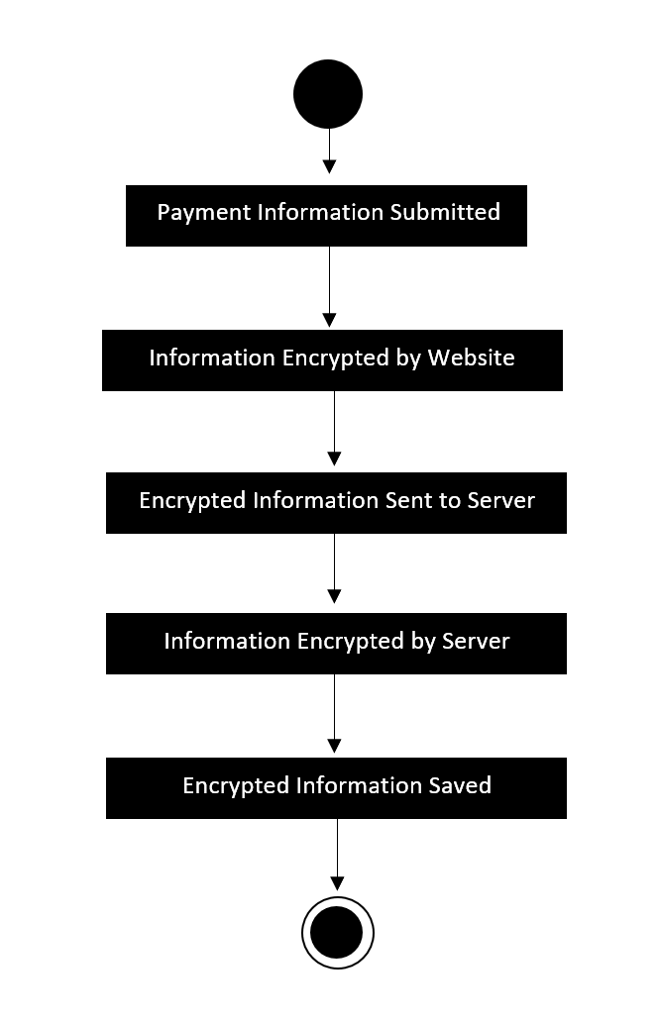

Step 5:

